**Steps To Run TestSuite on PIT**

1. First we should have PIT up and running and for that we should have proper configuration in pom.xml file to facilitate integration into maven.
2. In Pom.xml file mention the files that you want to test under <targetclass></targetclass> and mention the Junit files under <targettest></targettest> field.
3. If nothing is written then by default it will pick up the files from target/classes folder structure.
4. Open command line and go to the Project directory.
5. Type mvn org.pitest:pitest-maven:mutationCoverage and the command line will be shown as below:

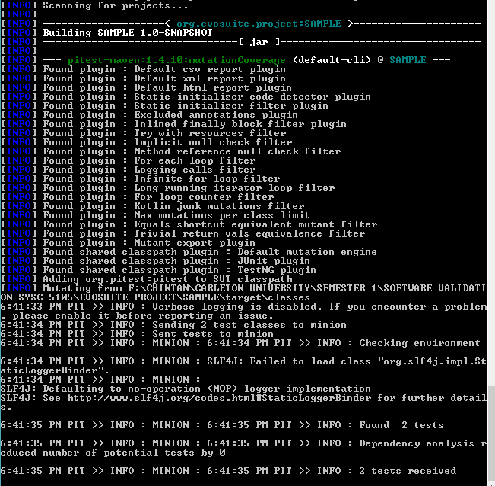

1. The PIT mutator operators and it’s details will be shown in command line as below:

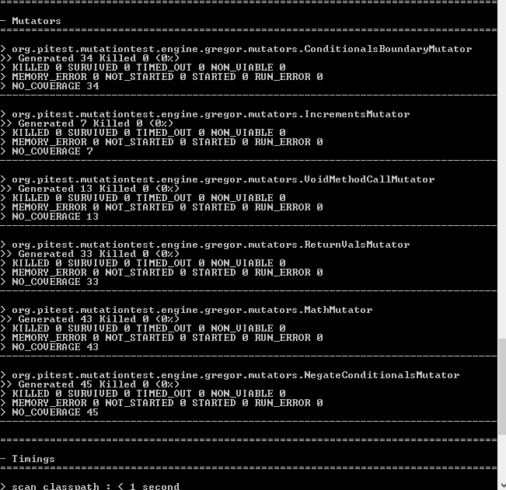

1. Total number of mutators generated will be shown as below: 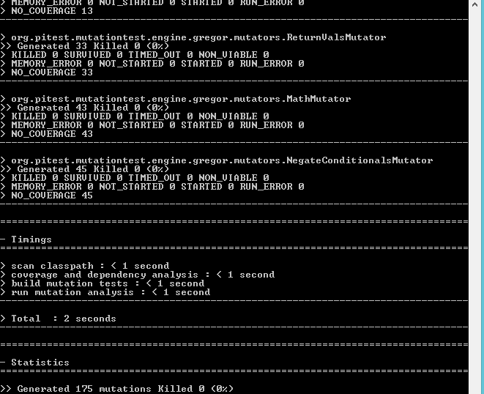

In this case we have generated 175 mutations.

1. Now to check how much coverage we have achieved, go to target/pit-reports/ . In this directory the report will be named as “YYYYMMDDHHMM”. Open the latest report and click on index.html.
2. This will give us the line coverage and mutation coverage as shown below: 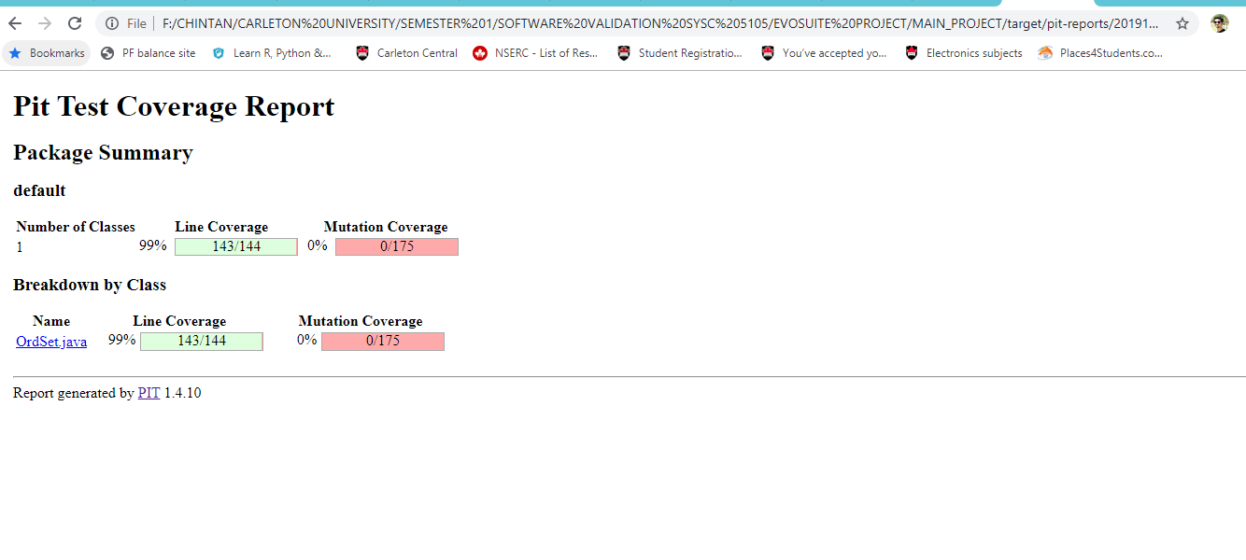
3. Click on OrdSet.java hyperlink, and it will show the details of mutators,

For Example: Survived, Killed, Active Mutators and time taken for test exection. All these parameter are shown in below figure. Light Green and light pink color shows that line coverage is successful and unsuccessfull respectively for each statement. Same way, Dark green and dark pink color shows that mutation is killed and survived respectively.

